**Dd todo:**

**Goto index.html to access the home page in VS code. Then use whatever GoLive page you’re on to hit the HOME button on its top menu. At that point, any chgs made in vs code for the home page will show up there.**

**The menu items: about, engineering, mus+eng, music, building olin – all appear to have subpages which you’ve been editing.**

**All supp mats and apps are embedded as links**

**Keep a list of every doc you’ve chged. I edited supp mat II-A-1. When ready, suki knows what to re-dl fr the green folder**

**Have to go back to my orig word docs for supp mats that you want to revise. Then put those in the green folder.**

**Put every doc you create or chg in the green folder. To get to the green folder: hit onedrive in lower rh corner. View online. Search “portfolio”, wait a bit, then put evth in “for Suki” green folder**

ESA – also add assignments to new Appendix II – B – 3

Signals – add assignments to new App II-B-4

TEO best paper

PFI-TT: add abstract o Appendix IV-H-4. Just add I-Corps abstract to Appendix IV-H-3

pats

HRI

CV

#concerts: update concerts on app IV-L 19-20, 21-22, 22-23, 23-24

Update on TEO ws Hub: arrangements 19-20, 21-22, 22-23, 23-24

Contact joe about missing links

Shd ev single video on the ws have its own youtube presence: also be stored in a repo with its own link so nothing’s dependent on olin’s ws or remember productions or my google drive?

Appendix IV-K-1: A Sampling of my Orchestral Arrangements **– add mussorgsky arrangement analysis + video to this appendix IV-K-1 and add score to appendix IV-K-2**

**10-11-24**

When accessed VS code (code .), got the following msg:

How to edit Supplementary files? This is what I see:

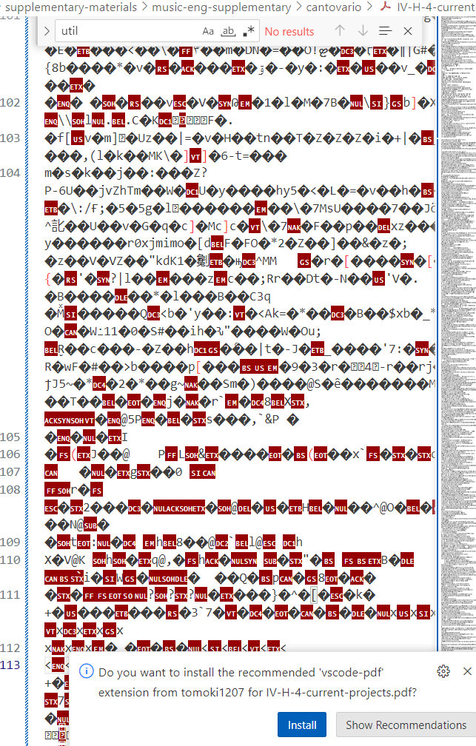

10-10-24

Links that don't work:

<http://127.0.0.1:5501/music-subpages/musical-works.html>

scores aren’t linked properly: Under PLDM (parallel lives – distant mirror) - The scores for all these performances can be found [here.](http://127.0.0.1:5501/website-documents/supplementary-materials/music-supplementary/III-G-musical-scores-commissions.pdf)

VS code:

 <p>The scores for all these performances can be found

<a

href="../website-documents/supplementary-materials/music-supplementary/III-G-musical-scores-commissions.pdf"

target="_blank">here.</a></p>

I'm using ctrl / to comment out text not directly relevant to the ws.

How to insert a line break?

<p>Four large projects comprise this section.

I used

<p></p> this works fine

<br></br> works too

How to unbold text:

<b> text </b> for bolded text

To unbold: remove <b> </b>

three overarching themes of lifelong learning, intrinsic motivation, and the creative process

I finished musical-works.html

How do i navigate in vs code from the home page to each succeeding page, in order, until the end?

Where do i find the supplementary materials to edit, e.g., adding new patents

steps:

CTRL+S to save your file before pushing.

To do this, first type git add . to add all of the modified files to what you’ll push. Press Enter.

Then, type git status to check if all of your changes have been added to the staging.

 type git commit -m ‘type commit message here’

Once your commits have been staged, you want to finally push them to the main branch. To do this, type git push

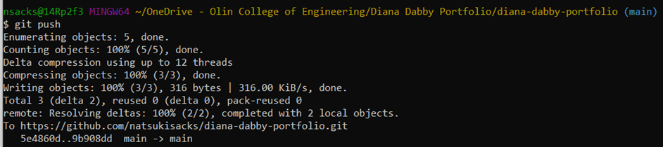

It shd look someth like the above.

If you’ve successfully pushed, the main repo should reflect that it’s been updated! You can check that [here:](https://github.com/natsukisacks/diana-dabby-portfolio) <https://github.com/natsukisacks/diana-dabby-portfolio>